Top of Form
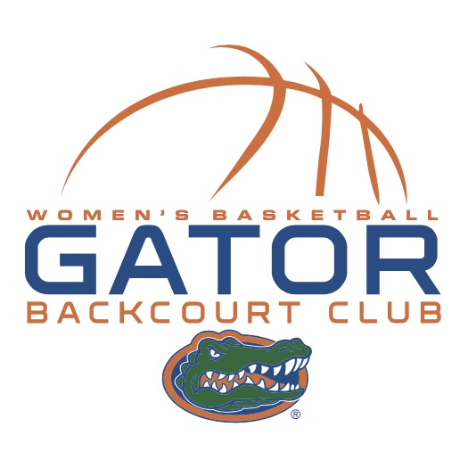 |  | Gator Backcourt Club Membership Application  2018-2019 Season  www.gatorbackcourtclub.com
Name: | ____________________________________________________________________________
Address: | ____________________________________________________________________________
City, State, Zip: | ____________________________________________________________________________
Home Phone: | ____________________________Cell Phone: _________________________________
Email: | ____________________________________________________________________________
 | (please print clearly)
 | I chose NOT to share my email with BCC members.
Membership Options (please select one):
Individual $30.00
Family - $50.00 (up to 2 persons, $5 for each additional person) – Please list below
Student - $5.00
Please indicate: Membership Renewal New Membership Gator Basketball Alumna

Additional Family Member Names & Email addresses:

(1) ________________________________________ (2) ____________________________________________
(3) ________________________________________ (4) ____________________________________________
I would like to assist the club in the following area(s):
Special Events Membership Game Day BCC Table
Payment Method (please check one)

Check: # amount $ (make checks payable to Backcourt Club)
Cash: amount $ (do not send cash via mail)
If you prefer to pay your dues via credit card, please visit: www.gatorbackcourtclub.com & click on the “membership” tab.

Bottom of Form
Mail application and payment to:
Ruth Dalton – BCC Secretary
1128 NW 106th St.
Gainesville, FL 32606

